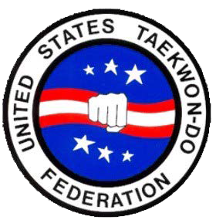
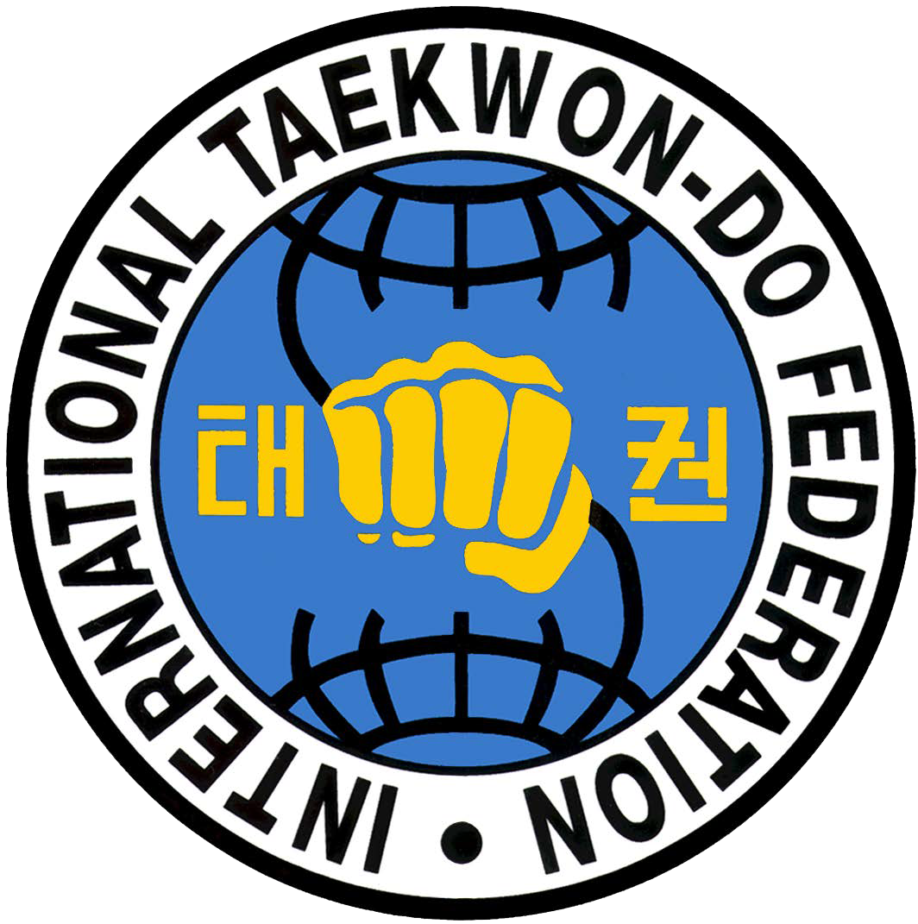
UCHTA

UTAH CHANG HUN TAEKWON-DO ALLIANCE

RELEASE AND WAVIER OF LIABILITY AND INDEMNITY AGREEMENT
(READ CAREFULLY BEFORE SIGNING)
In consideration of being permitted to participate in any way in the Martial Arts Program indicated below and/or being permitted to enter for any purpose any restricted are (here in defined as any area where in admittance to the general public is prohibited), the Participant (if and adult), or parent(s) and/or legal guardian(s) of the minor participant named below agree (if a minor):
- The Participant (if an adult) or parent(s) and/or legal guardian(s) will instruct the minor participant (if a minor) that prior to participating in the below martial arts activity or event, he or she should inspect the facilities and equipment to be used, and if he or she believes anything is unsafe, the participant should immediately advise the officials of such condition and refuse to participate. I understand and agree that, if at any time, I feel anything to be UNSAFE; I will immediately take all precautions to avoid the unsafe area and REFUSE TO PARTICIPATE further.
- I/We fully understand and acknowledge that:
  - There are risks and dangers associated with participating in martial arts events and activities which could result in bodily injury partial and/or total disability, paralysis and death.
  - The social and economic losses and/or damages, which could result from these risks and dangers described above, could be severe.
  - These risks and dangers may be caused by the action, inaction or negligence of the participant or the action, inaction or negligence of others, including, but not limited to, the Releasees name below.
  - There may be other risks not known to us or are not reasonably foreseeable at this time.
- I/WE accept and assume such risks and responsibility for the losses and/or damages following such injury, disability, paralysis or death, however caused and whether caused in whole or in part by the negligence of the Releasees named below.
- I/We HEREBY RELEASE, WAIVE, DISCHARGE AND COVENANT NOT TO SUE the martial arts facility used by the participant, including it owners, managers, promoters, lessees of premises used to conduct the martial arts event or program, premises and evaluation or loss control activities regarding the martial arts facility or events held at such facility and each of them, their directors, officers, agents, employees, all for the purpose herein referred to as “Releasee”… From all liability to the undersigned, my/our personal representatives, assigns, executors, heirs and next of kin For any and all claims, demands, losses or damages and any claims or demands therefore on account of any injury, including but not limited to the death of the participant or damage to property, arising out of or relating to the event(s) caused alleged to be caused in whole or in part by the negligence of the releasee or otherwise.
- I/We HEREBY acknowledge that THE ACTIVITIES OF THE EVENT(S) ARE VERY DANGEROUS and involve the risk of serious injury and/or death and/or property damage. Each of the UNDERSIGNED also expressly acknowledge that INJURIES RECEIVED MAY BE COMPOUNDED OR INCREASED BY NEGLIGENT RESCUE OPERATIONS OR PROCEDURES OF THE RELEASEES.
- EACH OF THE UNDERSIGNED further expressly agrees that the foregoing release, waiver, and indemnity agreement is intended to be as broad and inclusive as is permitted by the law of the Province or State in which the event is conducted and that if any portion is held invalid, it is agreed that the balance shall, notwithstanding continue in full legal force and effect.
- On behalf of the participant and individually, the undersigned partner(s) and/or legal guardian(s) for the minor participant executes this Waiver and Release. If, despite the release, the participant makes a claim against any of the Releasees, the parent(s) and/or legal guardian(s) will reimburse the Releasee for any money which they have paid to the participant, or on his behalf, and hold them harmless.

I HAVE READ THIS RELEASE AND WAIVER OF LIABILITY, ASSUMPTON OF RISK AND INDEMNITY AGREEMENT, FULLY UNDERSTAND ITS TERMS, UNDERSTAND THAT I HAVE GIVEN UP SUBSTANTIAL RIGHTS BY SIGNING IT, AND HAVE SIGNED IT FREELY AND VOLUNTARILY WITHOUT ANY INDUCEMENT, ASSURANCE, OR GUARANTEE BEING MADE TO ME AND INTEND MY SIGNATURE TO BE COMPLETE AND UNCONDITIONAL RELEASE OF ALL LIABILITY TO THE GREATEST EXTENT ALLOWED BY LAW. MARTIAL ARTS SCHOOL:

PARTICIPANT SIGNATURE: PARENT/GUARDIAN SIGNATURE: PRINTED NAME OF PARTICIPANT: ADDRESS OF PARTICIPANT:
OFFICE USE ONLY:

Received by: Signature Printed Name Date

